Unit 3 - Task #1
Solve the following problems using a strategy of your choice:

3 x 4 =

3 x 40 =

3 x 400 =

3 x 4,000 =

What pattern do you notice?

Explain how this pattern could be used to solve 7 x 3,000 using mental math.

I Can Statements:
- I can explain patterns in the product when multiplying by multiples of 10, 100, and 1000.
Unit 3 - Task #2

Rudy solved 4 x 15 using the following strategy:

4 x 10 = 40
4 x 5 = 20
40 + 20 = 60

Does it work? Explain your reasoning.

Use Rudy’s strategy to solve 4 x 22.

I Can Statements:
- I can multiply whole numbers using different strategies.
- I can represent the strategy that I used to solve my problem.
- I can explain the strategy that I used to solve my problem.
Unit 2 - Task #3

Use Rudy’s strategy from the previous task to solve the following problems.

- 3 x 246 =

- 5 x 4,212 =

Explain how the strategy works.

I Can Statements:
- I can multiply whole numbers using different strategies.
- I can represent the strategy that I used to solve my problem.
- I can explain the strategy that I used to solve my problem.
Unit 3 - Task #4

Carl solved the problem 6 x 482 and got a product of 2,892. Use estimation and/or rounding to determine if his answer is reasonable. Explain how you determined if the answer is reasonable.

I Can Statements:
- I can check to see if my answer is reasonable using estimation strategies.
Unit 3 - Task #5

Julian used place value blocks to solve 3 x 24. His work is below.

What is the product?

How is Julian’s strategy the same as Rudy’s and how is it different from Rudy’s?

I Can Statements:
- I can multiply whole numbers using different strategies.
- I can represent the strategy that I used to solve my problem.
- I can explain the strategy that I used to solve my problem.
Unit 3 - Task #6
Solve the following problems using a strategy of your choice:

20 x 3 =

20 x 30 =

20 x 300 =

20 x 3,000 =

What pattern do you notice?

Explain how this pattern could be used to solve 40 x 6,000 using mental math.

I Can Statements:
- I can explain patterns in the product when multiplying by multiples of 10, 100, and 1000.
Unit 3 - Task #7

Marcia picked oranges and put them in 12 bags. Each bag had 15 oranges. What is the total number of oranges Marcia picked? Use the centimeter grid paper to model this problem as a rectangular array. Label each part of the array.

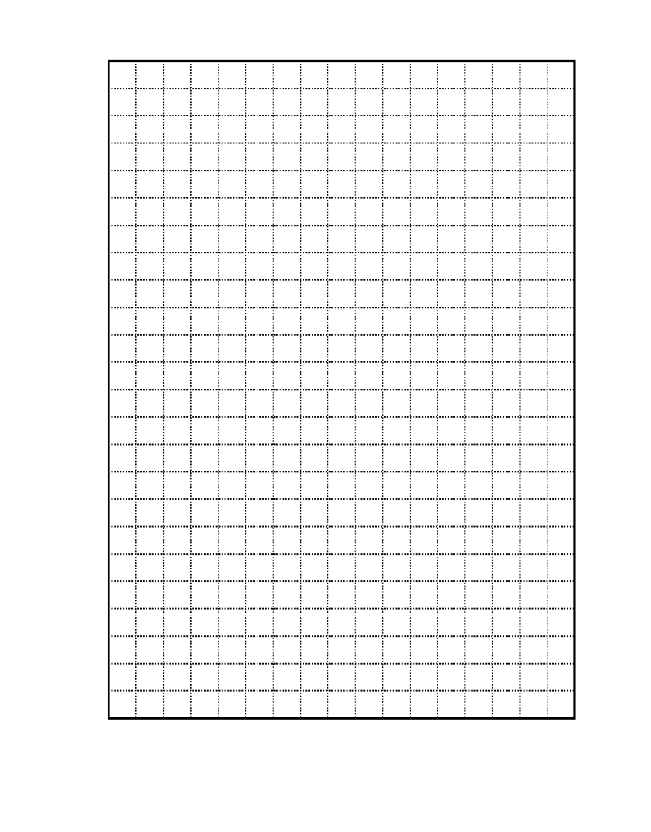

I Can Statements:
- I can multiply whole numbers using a rectangular array.
- I can represent the strategy that I used to solve my problem.
- I can explain the strategy that I used to solve my problem.
Unit 3 - Task #8

Part 1:
Compare the array for 24 x 32 with the rectangular representation of 24 x 32.

Array for 24 x 32:   | Rectangle for 24 x 32:  

How are they the same?

How are they different?

I Can Statements:
- I can multiply whole numbers using a rectangular array.
- I can represent the strategy that I used to solve my problem.
- I can explain the strategy that I used to solve my problem.
Unit 3 - Task #8

Part 2:
Melissa started to solve the problem 24 x 32 using the following model.
- What are some things you notice about her model?

- What side represents 24? What side represents 32?

- Look at her work so far and determine what still needs to be done to solve the problem.
30 +

600
20

+

Solve the problem using Melissa’s strategy. Explain how this strategy works.

I Can Statements:
- I can multiply whole numbers using an area model.
- I can represent the strategy that I used to solve my problem.
- I can explain the strategy that I used to solve my problem.
Unit 3 - Task #9

Jenna has 14 packs of gum with 12 pieces in each pack. She gives her friend Julia 31 pieces. How many pieces does she have left?
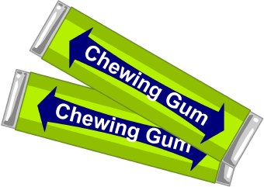

Explain how you solved the problem and write an equation(s).

I Can Statements:
- I can solve multi-step word problems using operations.
- I can represent the strategy that I used to solve my problem.
- I can explain the strategy that I used to solve my problem.
Unit 3 - Task #10

Mrs. Tammy has 32 students. She wants to know all the possible combinations to arrange her students in equal rows. Record the arrays and explain how you came up with the different arrangements.
Unit 3 - Task #10

Explain how you came up with the different arrangements.

I Can Statements:
- I can find all the arrays of a given product.
Unit 3 - Task #11

Use math tiles and grid paper to help solve the following task:
- Find all of the multiplication expressions and the corresponding rectangular arrays for numbers 10 through 25.

- Record the rectangles on grid paper. Label each rectangle with the number of squares and a multiplication equation. Group together all arrays with the same number of squares.

- Which numbers have the least number of arrays and, therefore, the least number of factors?

- Which numbers have only a factor of 1 and itself?

- Which numbers have arrays that form a square?

I Can Statements:
- I can find all the factor pairs of a given product.
- I can find the pattern in factor pairs of products.
Unit 3 - Task #11

Unit 3 - Task #12

Use a hundreds chart:
- Shade the number 1 red.
- Circle the first unmarked number.
- Cross off every multiple of that number except the one you circled. If it’s already crossed off, skip it.
- Repeat steps 2 and 3 until every number is circled or crossed off.
- Shade every crossed out number in orange.
- List the circled numbers.

- Why are the circled numbers not crossed off along the way?

- Except for number 1, what is similar about all of the numbers that were crossed off?

- What is similar about all of the numbers that were circled?

I Can Statements:
- I can find all the factor pairs of a given product.
- I can find the pattern in factor pairs of products.
Unit 3 - Task #12

Hundreds Chart

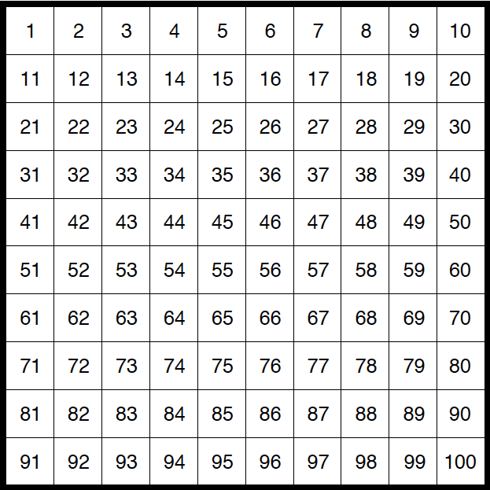

Unit 3 - Task #13

Mr. Diaz ordered a supply of 320 crayons. He needs to divide them equally among 4 art classes. How many crayons does each art class get?


Explain how you solved the problem.

I Can Statements:
- I can solve word problems using operations.
- I can represent the strategy that I used to solve my problem.
- I can explain the strategy that I used to solve my problem.
Unit 3 - Task #14

Jose has 272 hockey cards to arrange in 9 boxes. Each box is to hold the same number of cards. Estimate to find about how many hockey cards will be placed in each box.
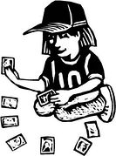

Explain how you solved the problem.

I Can Statements:
- I can solve word problems using operations.
- I can check to see if my answer is reasonable using estimation strategies.
- I can explain the strategy that I used to solve my problem.
Unit 3 - Task #15

Three friends go to a video arcade and win 248 tickets altogether. They decide to split the tickets equally. About how many tickets will each friend get?
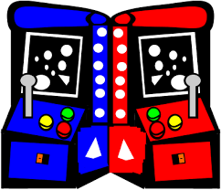

Explain how you solved the problem.

I Can Statements:
- I can solve word problems using operations.
- I can check to see if my answer is reasonable using estimation strategies.
- I can explain the strategy that I used to solve my problem.
Unit 3 - Task #16

Jimi Has 3,000 tickets for rides at the school carnival. Jimi needs to pack small plastic bags with 8 tickets in each bag. About how many bags will he need?
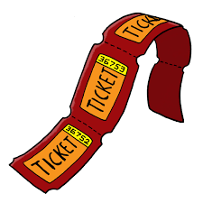

Explain how you solved the problem.

I Can Statements:
- I can solve word problems using operations.
- I can check to see if my answer is reasonable using estimation strategies.
- I can explain the strategy that I used to solve my problem.
Unit 3 - Task #17

Grace can put 6 pictures on one page of her photo album. If she has 82 pictures, how many pages will she need?
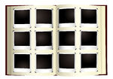

Explain how you solved the problem.

I Can Statements:
- I can solve word problems using operations.
- I can represent the strategy that I used to solve my problem.
- I can explain the strategy that I used to solve my problem.
Unit 3 - Task #18

Mrs. Miller was about to buy a packet of Starbursts for her class. She wanted to make sure she had enough for everyone so she looked at the nutrition label.

- How many Starbursts are in a bag?

- How many Starbursts will each student in the class receive if there are 28 kids in her class?

- Will any Starbursts be left over? If so, what can your teacher do about the left over Starbursts?

I Can Statements:
- I can solve word problems using operations.
- I can represent the strategy that I used to solve my problem.
- I can explain the strategy that I used to solve my problem.
Unit 3 - Task #18 - Starbursts Nutrition Label

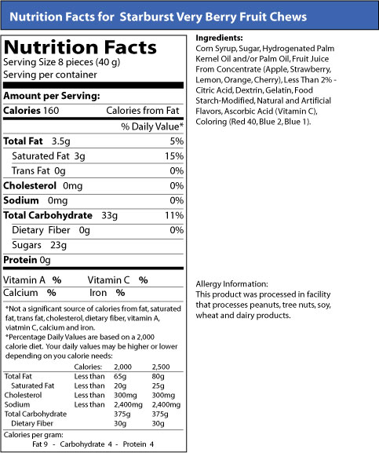

10

Unit 3 - Task #19

A bag of candy has 783 jellybeans. Aiden and his four friends want to share them equally. How many jellybeans will Aiden and each of his friends get?
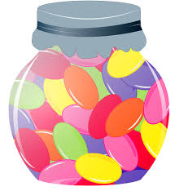

Explain how you solved the problem.

I Can Statements:
- I can solve word problems using operations.
- I can represent the strategy that I used to solve my problem.
- I can explain the strategy that I used to solve my problem.
Unit 3 - Task #20

John was solving the following problem:
- A 4th grade teacher bought 4 new pencil boxes. She has 260 pencils. She wants to put the pencils in the boxes so that each box has the same number of pencils. How many pencils will there be in each box?

This is how he solved it:
- 4 x 50 = 200
- 4 x 10 = 40
- 4 x 5 = 20
- 50 + 10 + 5 = 65
- So, 260 ÷ 4 = 65

Explain John’s strategy. Does it work? Why or why not?

I Can Statements:
- I can find the quotient for a division problem that can have up to 4 digit dividends and 1 digit divisors using different strategies.
- I can represent the strategy that I used to solve my problem.
- I can explain the strategy that I used to solve my problem.
Unit 3 - Task #21

Second grade students are putting on a concert, and the principal has asked our class to set up chairs in the café for parents and guests. We have 256 chairs, and the principal wants rows with 8 chairs in each row. How many rows do we need to set up? Use grid paper to solve this problem.


I Can Statements:
- I can solve word problems using operations.
- I can represent the strategy that I used to solve my problem.
- I can explain the strategy that I used to solve my problem.
Unit 3 - Task #22

Anthony was solving the following problem:
- A theater has 245 seats arranged in rows with 7 seats in each row. How many rows are in this theater?

This is how he decided to represent the problem:

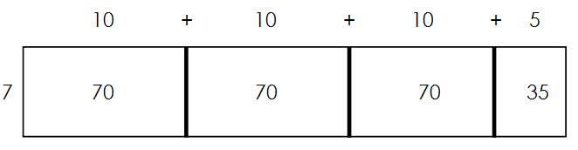

Explain Anthony’s strategy. What would be his final answer?

I Can Statements:
- I can find the quotient for a division problem that can have up to 4 digit dividends and 1 digit divisors using different strategies.
- I can represent the strategy that I used to solve my problem.
- I can explain the strategy that I used to solve my problem.
Unit 3 - Task #23

Mariam was solving the following problem:
Solve 774 ÷ 3 beginning with the following first step: 3 x 200.

This is how she solved it:

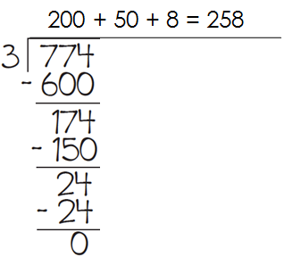

Explain Mariam’s strategy. Does it work? Why or why not?

I Can Statements:
- I can find the quotient for a division problem that can have up to 4 digit dividends and 1 digit divisors using different strategies.
- I can represent the strategy that I used to solve my problem.
- I can explain the strategy that I used to solve my problem.

